Eproject

E-Project for Semester No.4

---

VIETNAMJOBS

---

|  |  |
| --- | --- |
| **Authors** | **Aptech – C2110L - Group :ABC Team** |
| 1. Tu Le Thanh - Student1341374 [(Leader)] 2. Ai Phan Hoang Kha - Student1322677 3. Huong Truong Van - Student1352753 4. Loc Tan Tran - Student1352787 5. Hieu Nguyen Trong - Student1352773 |
| **Centre Name** | Aprotrain Aptech HCMC D5 Binh Thanh |
| **Date** | 16 - May - 2024 |
| Course | ACCP |
| Curriculum Code | OV-ACCP-7023-ACE |
| **Semester** | Semester 4 |
| **Instructor** | PHAN HUU TRI |

**Ho Chi Minh City, 17/05/2024**

**TABLE OF CONTENTS**

Clearly organized list of document sections and subsections

1. **Introduce eProject – Project name:** 3
2. Problem definition of project 3
3. List of Inputs to the Website 3
4. List of Outputs Expected from the Website 3
5. Overview of Processes Involved in the Website 3
6. Hardware and Software Required for Implementing the Project 4
7. Flow chart 4
8. Table assigning tasks to members (Leader) 5
9. **Instruction to run the project** 6
   1. Import database and tables into SQL Server 6
   2. Import Project into Visual Studio 7
   3. Run Web Application (Web Admin): 9
10. *Login 9*
11. *Manage Information of Claims/ Orders/ Customers 10*
    1. Run Web Application (Web User): 14
12. *Home Page 15*
13. *Login 17*
14. *Forgot Password 18*
15. *Register 19*
16. *Profile/Personal Order/ Change Password/ Logout 19*
17. *Insurance Plan Page 21*
18. *About Us Page 29*
19. *Contact Us Page 30*
    1. Database 29
20. *ER Diagram 29*
21. *Detail of Tables 30*
    1. Contributions 32

**INTRODUCE EPROJECT – PROJECT NAME**

* + - 1. **Problem definition of project:** (Introduce project)

A website and accompanying app address the following needs: assisting job seekers in finding employment opportunities, while also providing tools for employers to post and manage job listings based on specific requirements. The website and app should be clear, user-friendly, easily accessible, and navigable.

**Project Name: Job Seeker Assistance and Job Listing Platform**

**a.Objective**:

- Develop a website and mobile application to assist job seekers in finding employment opportunities.

- Provide tools for employers to post and manage job listings based on specific requirements.

- Create a clear, user-friendly, easily accessible, and navigable interface on both the website and app.

**b.Key Requirements**:

* Interface for Job Seekers:
* Job search functionality based on location, industry, salary range, etc.
* Ability to create and manage personal profiles.
* Detailed job information including job descriptions, requirements, and benefits.
* Online application feature and submission of resumes via email or application system.
* Interface for Employers:
* Job posting and management functionality.
* Candidate search and resume viewing capabilities.
* Handling candidate applications and managing the recruitment process.
* Administrative Interface:
* Content management tools for the website and application.
* Statistics and reporting on the activities of job seekers and employers.
* System updates and maintenance to ensure stability and security.

**c.Interface Design:**

* User-friendly interface, easy to use on both computers and mobile devices.
* Attractive colors and images suitable for the purpose of the website and application.
* Smooth user experience without errors.

**d.Development and Deployment:**

* Development of the website and application using appropriate and maintainable technologies.
* Thorough testing to ensure stability and meet user requirements.
* Deployment and maintenance of the system in a production environment.
  + - 1. **List of Inputs to the Website:**
* Admin:
* Admin account (username, password and information)
* Content management information (posts, news, announcements)
* User information management (job seekers, employers)
* User and admin access control
* User activity reports (visits, applications, interactions)
* Updating and maintaining the website's database
* Managing statistics and analytics data
* Adjusting website and app settings and options
* Handling support requests and user feedback
* Managing advertisements and related services
* Sending notifications and communications to users and employers
* Managing payment system and transactions
* Creating and managing forms, email templates, and other communication content with users and employers.
* Updating and maintaining website and app features and versions.
* User:
* Registration details (name, email, password and information)
* Personal information for creating a profile
* Resume/CV file upload
* Search queries for job searches (keywords, location, industry)
* Filters for refining job search results (salary range, job type, experience level)
* Application forms for specific job listings
* Contact forms for inquiries or support requests
* Account settings/preferences (notification preferences, password changes)
* Multimedia files (images, videos) for enhancing profiles or applications
* Payment information for premium services or job postings (if applicable)
* Interaction with website features such as liking, sharing, or bookmarking job listings.
  + - 1. **List of Outputs Expected from the Website**
* Admin:
* User management:
* Ability to view, edit, and delete user accounts.
* Access to user profile information.
* Monitoring user activity and interactions.
* Content management:
* Editing, or deleting posts, news, announcements.
* Managing job listings and employer profiles.
* Analytics and reporting:
* Generating reports on website traffic, user engagement, and job listing performance.
* Analyzing trends and patterns in user behavior.
* Communication:
* Sending notifications and updates to users and employers.
* Responding to inquiries, feedback, and support requests.
* Payment management:
* Tracking payments for premium services or job postings.
* Managing billing and invoicing.
* Data backup and recovery:
* Implementing regular backups of website data.
* Ensuring mechanisms for data recovery in case of system failures or data loss.
* Compliance and security:
* Ensuring compliance with data protection regulations.
* Monitoring and addressing security vulnerabilities and threats.
* User support and assistance:
* Providing guidance and assistance to users navigating the website.
* Resolving issues or concerns raised by users or employers.
* User:
* Job search results:
* List of relevant job openings matching the user's search criteria.
* Detailed job information:
* Job descriptions, requirements, salary, location, and benefits.
* Personal profile:
* User's personal information, skills profile, and job history.
* Resume submission and job application:
* Confirmation of successful resume submission or job application.
* Notifications and updates:
* Receive notifications about new job listings, application status, or other relevant information from the system.
* Interaction with jobs:
* Like, share, or bookmark favorite job listings.
* Contact with employers:
* Send mails or request contact information with employers.
* Personal settings:
* Adjust notification settings, update personal information, or change passwords.
* Payments
* Confirmation of payments for premium services or job postings.
* Support and guidance:
* Request support or receive guidance from the website as needed.
  + - 1. **Overview of Processes Involved in the Website**
* **Requirement Gathering and Planning:** This initial phase involves understanding the client's or organization's requirements, goals, target audience, and budget. It also involves creating a project plan, including timelines, milestones, and resource allocation.
* **Design:** Designing the website involves creating wireframes, mockups, and prototypes to visualize the layout, user interface, and user experience. This phase also includes choosing color schemes, typography, and other visual elements.
* **Frontend Development:** Frontend development involves translating the design into code using HTML, CSS, and JavaScript. This includes making the website responsive, ensuring it works across different devices and screen sizes.
* **Backend Development:** Backend development involves building the server-side logic and database management to support the website's functionality. This may involve using programming languages like Java, Dart as well as frameworks like Spring frameworks, Flutter framework.
* **Content Creation and Integration:** Content creation involves writing and organizing text, images, videos, and other media to populate the website.
* **Testing:** Testing is a crucial phase to identify and fix any bugs, errors, or usability issues in the website. This includes functionality testing, cross-browser testing, and performance testing to ensure the website works smoothly.
* **Deployment:** Deployment involves making the website live and accessible to users. This may involve setting up web hosting, configuring servers, and domain registration.
* **Maintenance and Updates:** Once the website is live, it requires ongoing maintenance to ensure security, performance, and functionality. This includes updating software, fixing bugs, adding new features, and optimizing performance.
* **Security:** Ensuring the security of the website involves implementing measures to protect against cyber threats, such as malware, hacking, and data breaches. This includes using secure coding practices, SSL certificates, and regular security audits.

These processes are often iterative, with feedback and revisions occurring throughout the development lifecycle to ensure the final product meets the client's or organization's requirements and goals.

* + - 1. **Hardware and Software Required for Implementing the Project**
* Hardware:
* **Servers:** Depending on the expected traffic and scalability requirements, you may need one or more servers to host the web application and database. . However for convenience, Operating System used is Window Server.
* **Networking Equipment:** Routers, switches, and firewalls may be necessary to manage network traffic and ensure security.
* **Storage:** Sufficient storage space is needed to store website files, user data, job listings, and other content.
* **Computers:** Development and testing environments will require computers or laptops for developers to write code, design interfaces, and test functionality.
* Software:
* **Operating System:** The choice of operating system for servers could be Linux distributions like Ubuntu, CentOS, or Debian, or Windows Server depending on the preferences and compatibility with the technology stack. However for convenience, Operating System used is Window Server.
* **Web Server:** Software such as Apache HTTP Server, Nginx, or Microsoft Internet Information Services (IIS) may be used to serve web pages and handle HTTP requests. However for convenience, Web Server used is Local Web Server.
* **Database Management System (DBMS):** A relational database management system (RDBMS) such as MySQL.
* **Programming Languages and Frameworks:** programming languages used is Java, Dart, along with frameworks is Spring, Flutter used for backend development. HTML, CSS, and JavaScript frameworks/libraries like React.js or Angular may be used for frontend development.
* **Version Control System:** Tools like Git or SVN are essential for managing source code versions, collaboration among team members, and tracking changes.
* **Development Tools:** Integrated Development Environments (IDEs) like Eclipse, Android Studio along with text editors, debugging tools, and command-line utilities are used for writing, debugging, and testing code.
  + - 1. **Flow chart of User**
* Admin:

a/Start:

Administrator accesses the admin panel of the platform.

b/User Management:

Admin manages user accounts, including:

* Editing existing user profiles.
* Deactivating or deleting accounts if necessary.

c/Job Listing Management:

Admin manages job listings, including:

* Editing existing job listings.
* Removing outdated or irrelevant job listings.

d/Employer Management:

Admin manages employer accounts, including:

* Verifying new employer registrations.
* Handling account-related issues.
* Deactivating or removing employer accounts if necessary

e/User Support:

* Admin provides support to users encountering issues with the platform.
* Responds to inquiries, troubleshoots problems, and provides guidance.

f/Data Analysis:

Admin analyzes platform usage data, including:

* User engagement metrics.
* Job application trends.
* Popular job categories.
* User feedback and suggestions.

g/Platform Maintenance:

Admin ensures the smooth operation of the platform by:

* Monitoring server performance.
* Updating software and security measures.
* Fixing bugs and addressing technical issues.

h/Community Engagement:

Admin engages with the platform community, including:

* Posting announcements or updates.
* Interacting with users and employers on forums or social media.
* Soliciting feedback and suggestions for platform improvement.

i.End:

Process ends.

* User:

a/Start:

* User accesses the job seeker assistance and job listing platform.

b/User Registration:

* User creates an account or logs in if they already have one.
* Verify user's email.

b/Profile Creation:

* User fills out personal information, education, work experience, skills, etc.

d/Job Search:

* User searches for jobs based on criteria like location, industry, job type, etc.

e/Job Listings:

* Platform displays relevant job listings based on user's search criteria.
* Listings may include job title, company, location, salary, and brief description.

f/Job Details:

* User clicks on a job listing to view more details about the job.

g/Application:

* User decides to apply for the job.
* If required, user uploads resume and cover letter.

h/Submit Application:

* User submits the application through the platform.

i/Confirmation:

* User receives confirmation of application submission.

j/Employer Review:

* Employers review applications submitted through the platform.

k/Interview:

* If selected, user may be contacted by the employer for an interview.

l/Job Offer:

* If successful, user may receive a job offer through the platform.

m/Job Acceptance:

* User may accept or reject the job offer.

n/End:

* Process ends.
  1. **Table assigning tasks to members (for Leader)**

|  |  |  |  |  |  |
| --- | --- | --- | --- | --- | --- |
| **No** | **Function** | **Details** | **Level** | **Recipient** | **Note** |
| **Database** | | | | | |
| 1 | Create Database |  | Medium | All |  |
| 2 | Drawing Diagram |  | Low | All |  |
| **Guest (No Login)** | | | | | |
| 1 | Main Page |  | Medium | Mr. Hieu |  |
| 2 | Login, Logout, Register |  | Medium | Mr. Huong |  |
| 3 | Employer Page |  | Medium | Mr. Hieu |  |
| 4 | Posting Page |  | Medium | Mr. Hieu, Mr. Tu, Mr. Huong |  |
| **Seeker** | | | | | |
| 1 | Profile Page |  | Medium | Mr. Hieu |  |
| 2 | Application Page |  | High | Mr. Hieu |  |
| 3 | Upload CV Information |  | High | Mr. Tu |  |
| 4 | Search Posting |  | High | Mr. Hieu, Mr. Tu |  |
| **Employer** | | | | | |
| 1 | Create Information Company |  | Low | Ms. Ai, Mr. Huong |  |
| 2 | Update Information |  | Medium | Ms. Ai, Mr. Huong |  |
| 3 | Create and Update Posting |  | Medium | Ms. Ai, Mr. Huong |  |
| 4 | Application List |  | Medium | Mr. Huong |  |
| 5 | Payment Page |  | Medium | Mr.Tu, Mr. Huong |  |
| **Admin** | | | | | |
| 1 | Main Page |  | Medium | Ms. Ai |  |
| 2 | Account Management |  | Medium | Ms. Ai |  |
| 3 | Posting Management |  | Mediun | Ms. Ai |  |
| 4 | Seeker and Employer Management |  | Medium | Ms. Ai |  |
| **App Mobile** | | | | | |
| 1 | Login, Logout, Register |  | Medium | Mr. Loc, Mr. Tu |  |
| 2 | Profile Page |  | Medium | Mr. Loc, Mr. Tu |  |
| 3 | Posting List Page |  | Medium | Mr. Loc, Mr. Tu |  |
| 4 | Employer List Page |  | Medium | Mr. Loc, Mr. Tu |  |
| 5 | Application History |  | Medium | Mr. Loc, Mr. Tu |  |

**INSTRUCTION TO RUN THE PROJECT**

1. **Import database and tables into SQL Server**

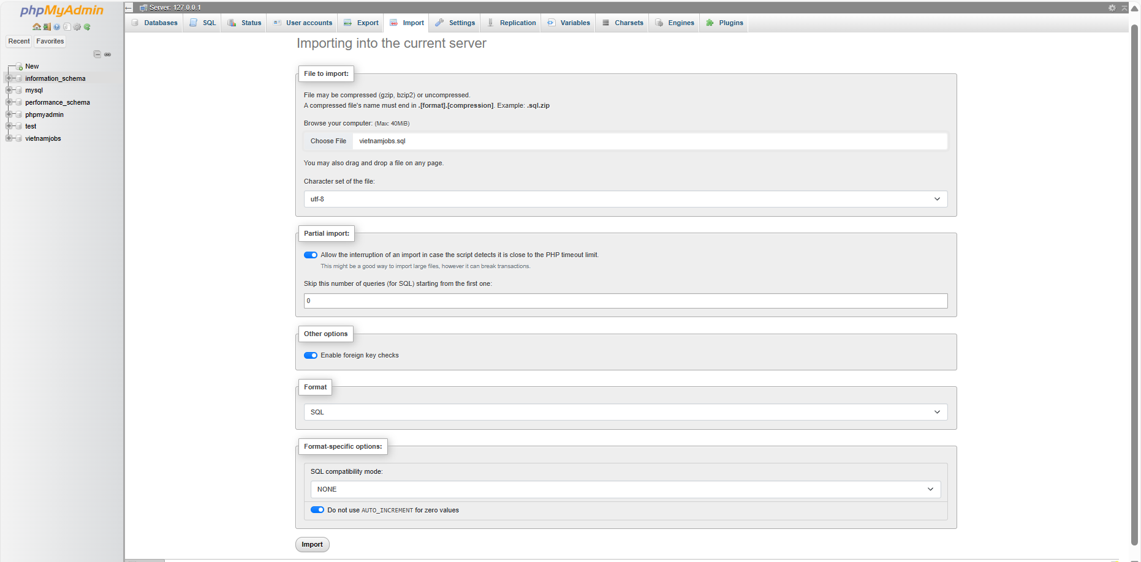

1. **Import Project into Spring**

Select File => Import => Maven => Existing Maven Project

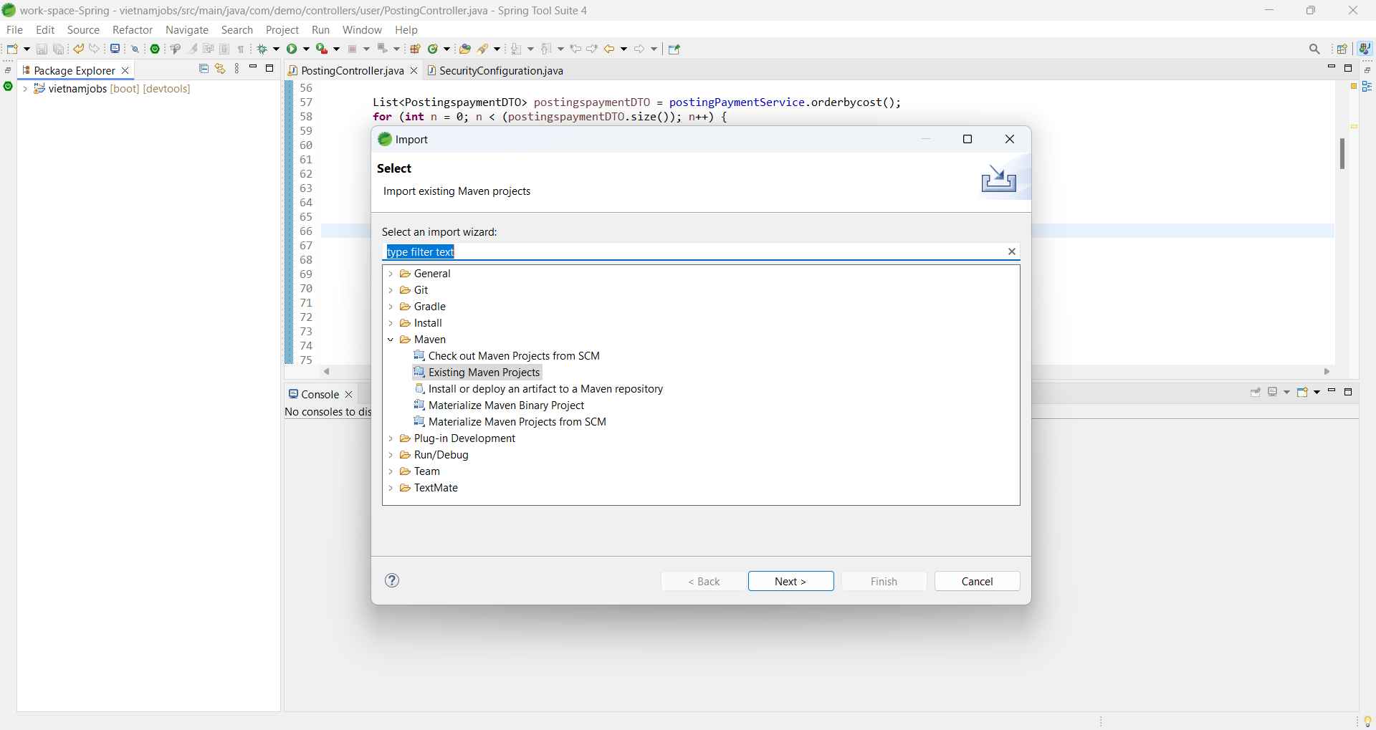

Choose path in Browse => Finish

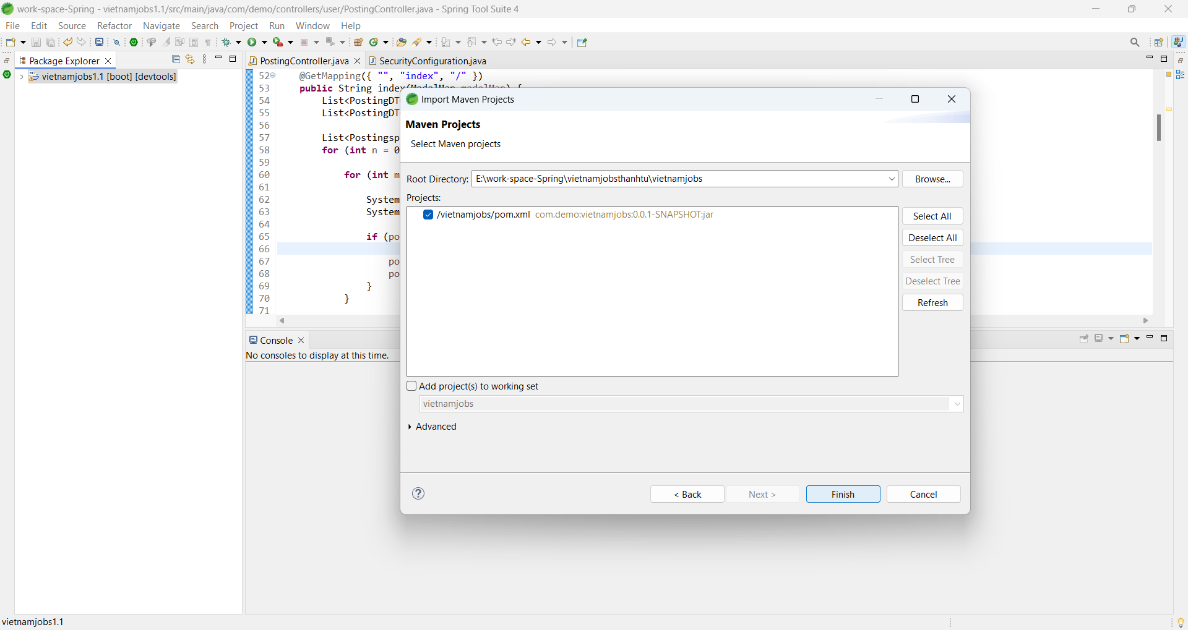

1. **Run Web Application (Web Admin):**
2. Login

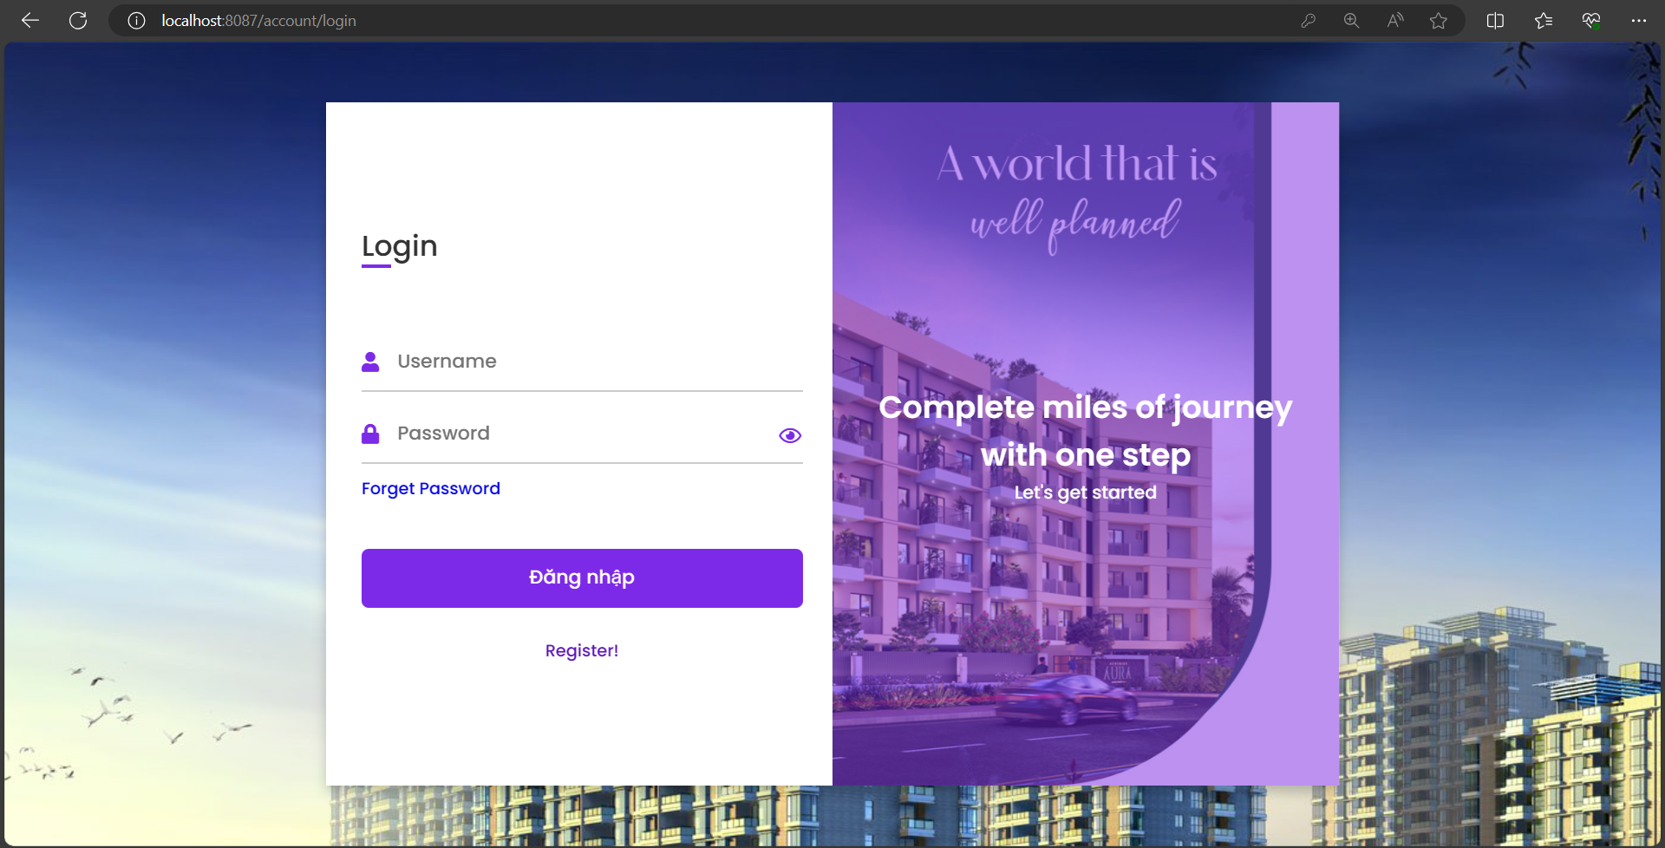

1. Manage Information of Claims/Customers/ Orders

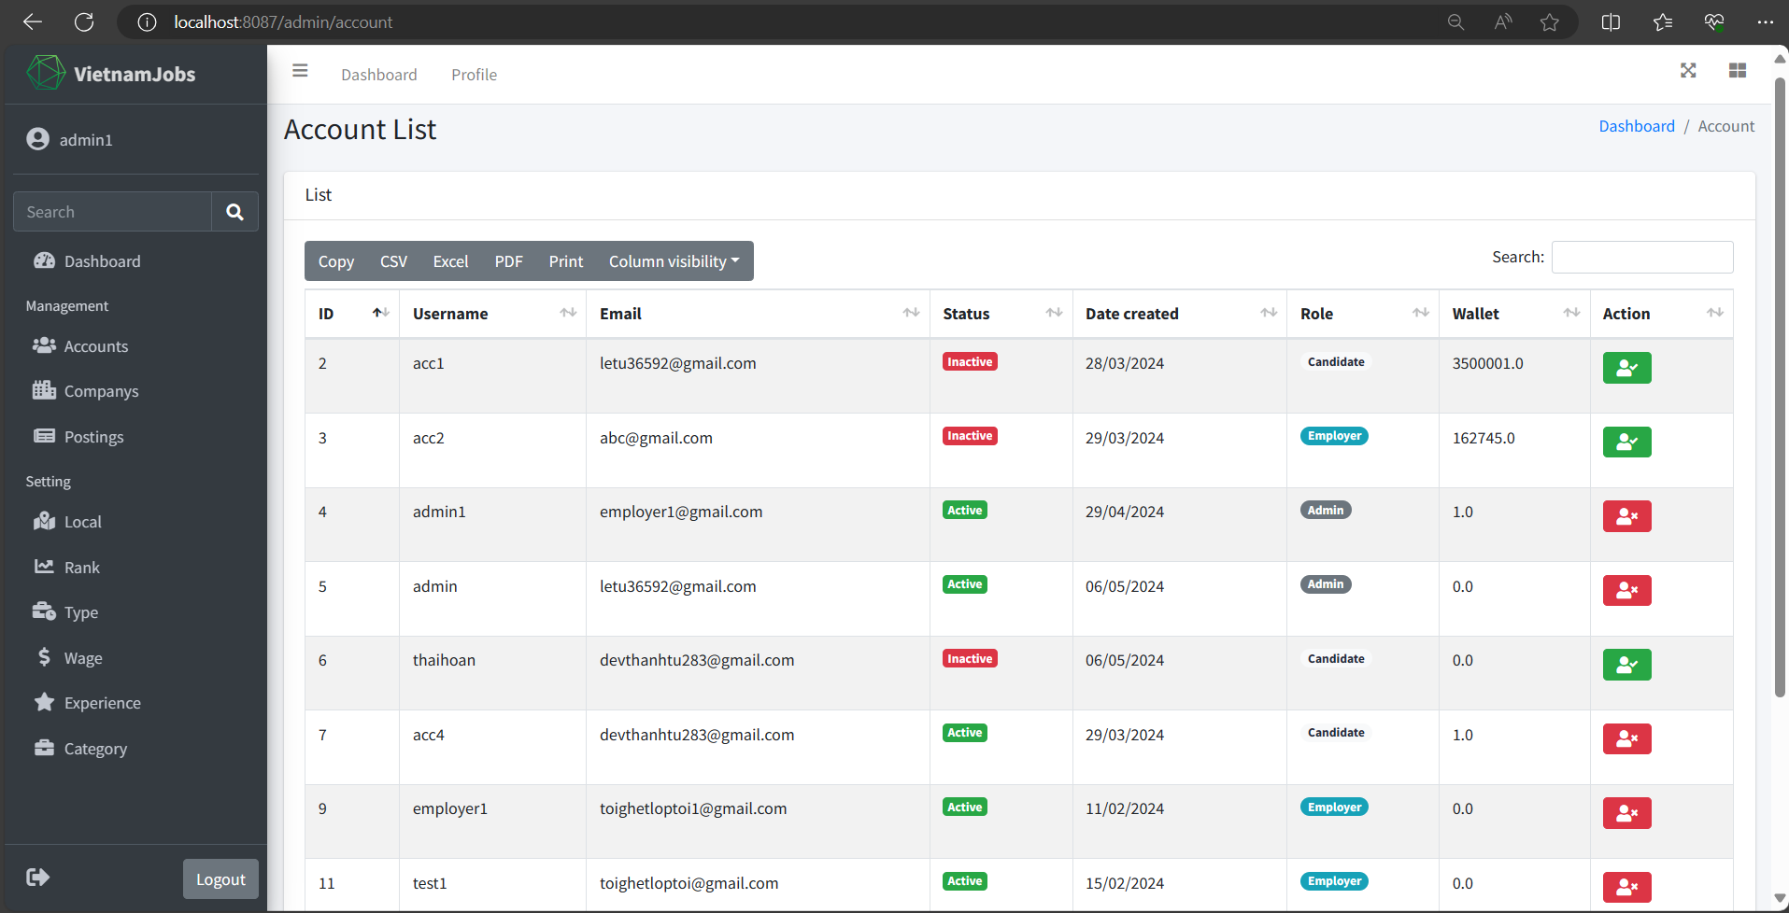

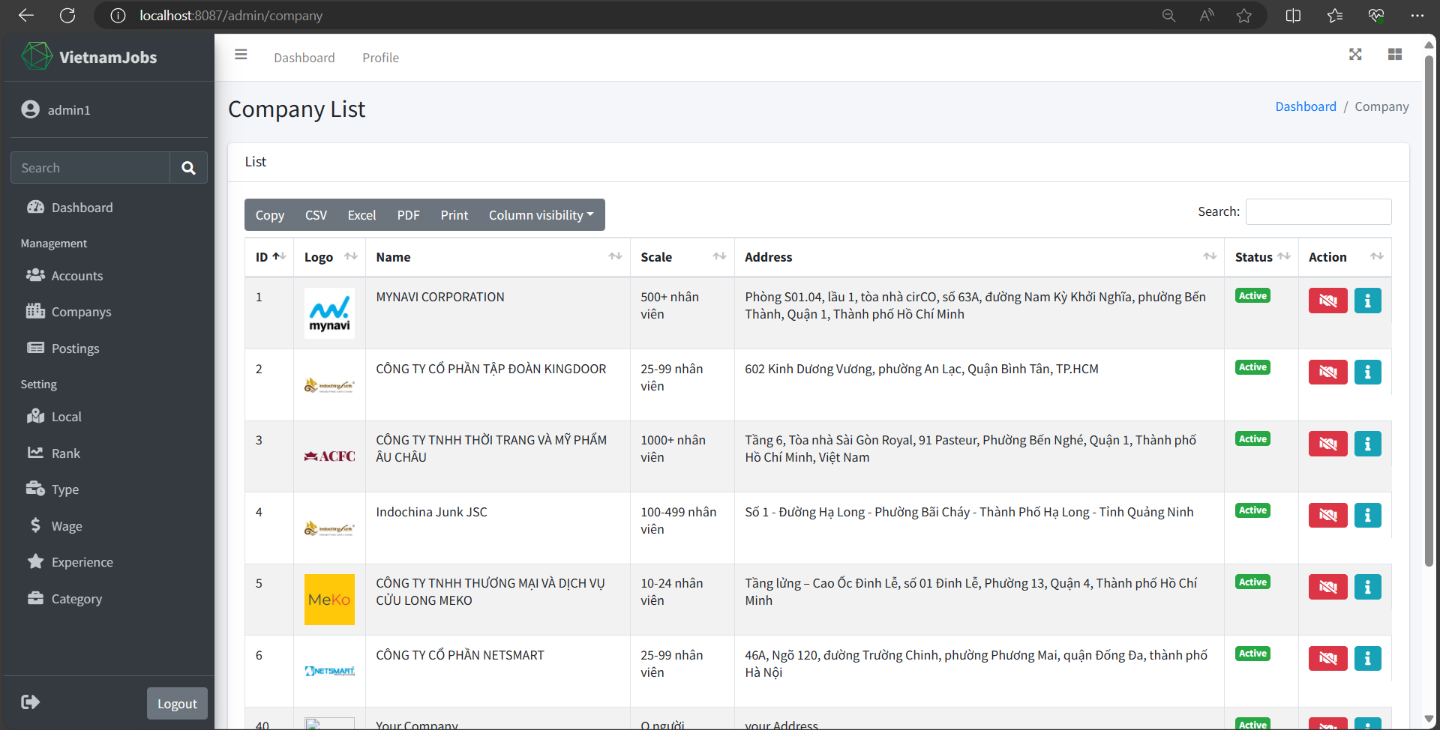

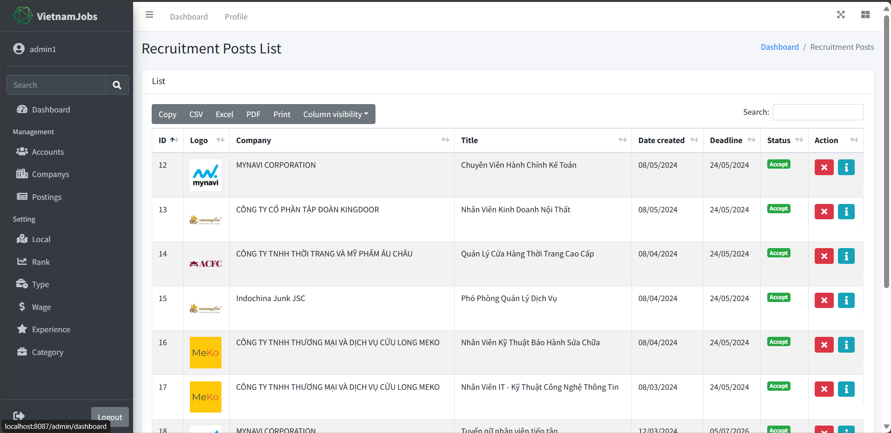

1. **Run Web Application (Web User):**
2. Home Page:

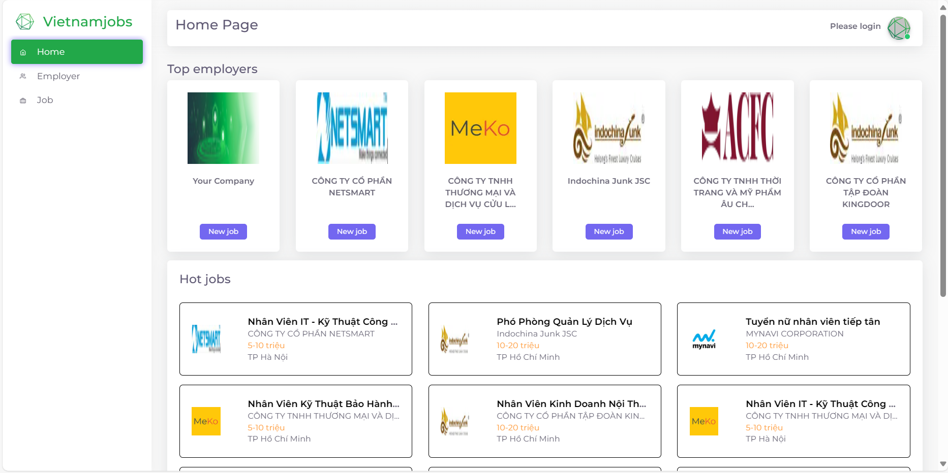

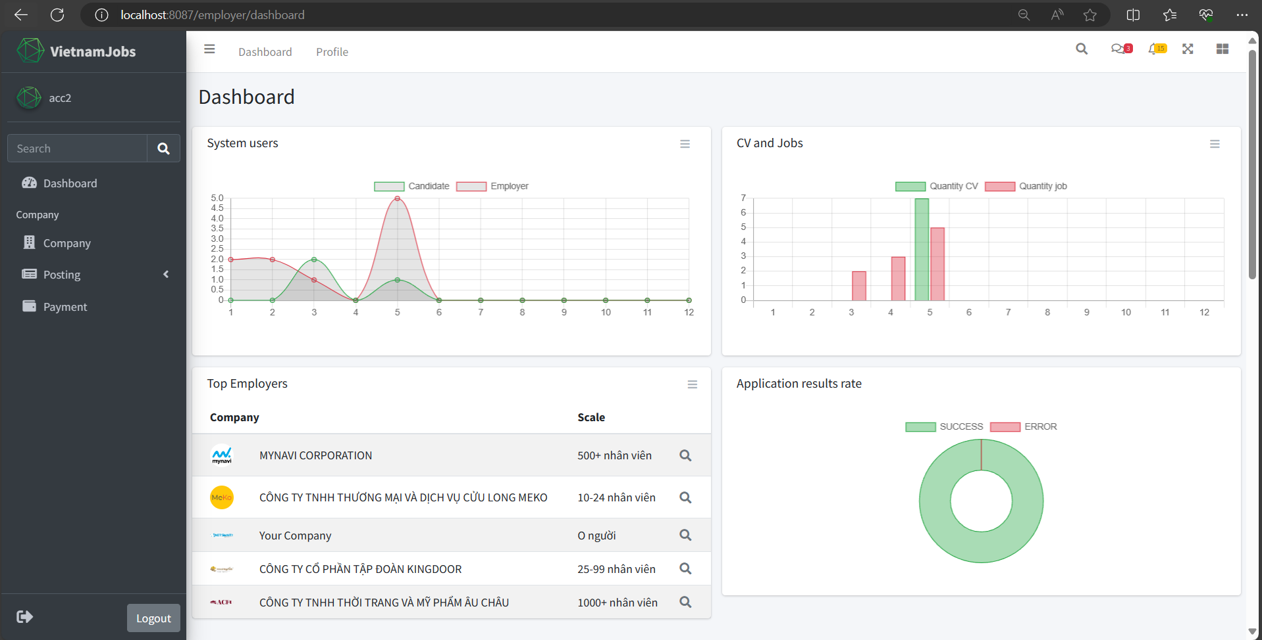

1. Login

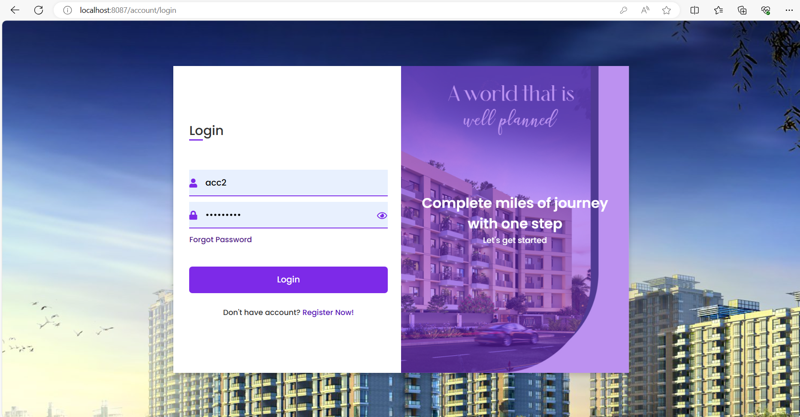

1. Forgot Password

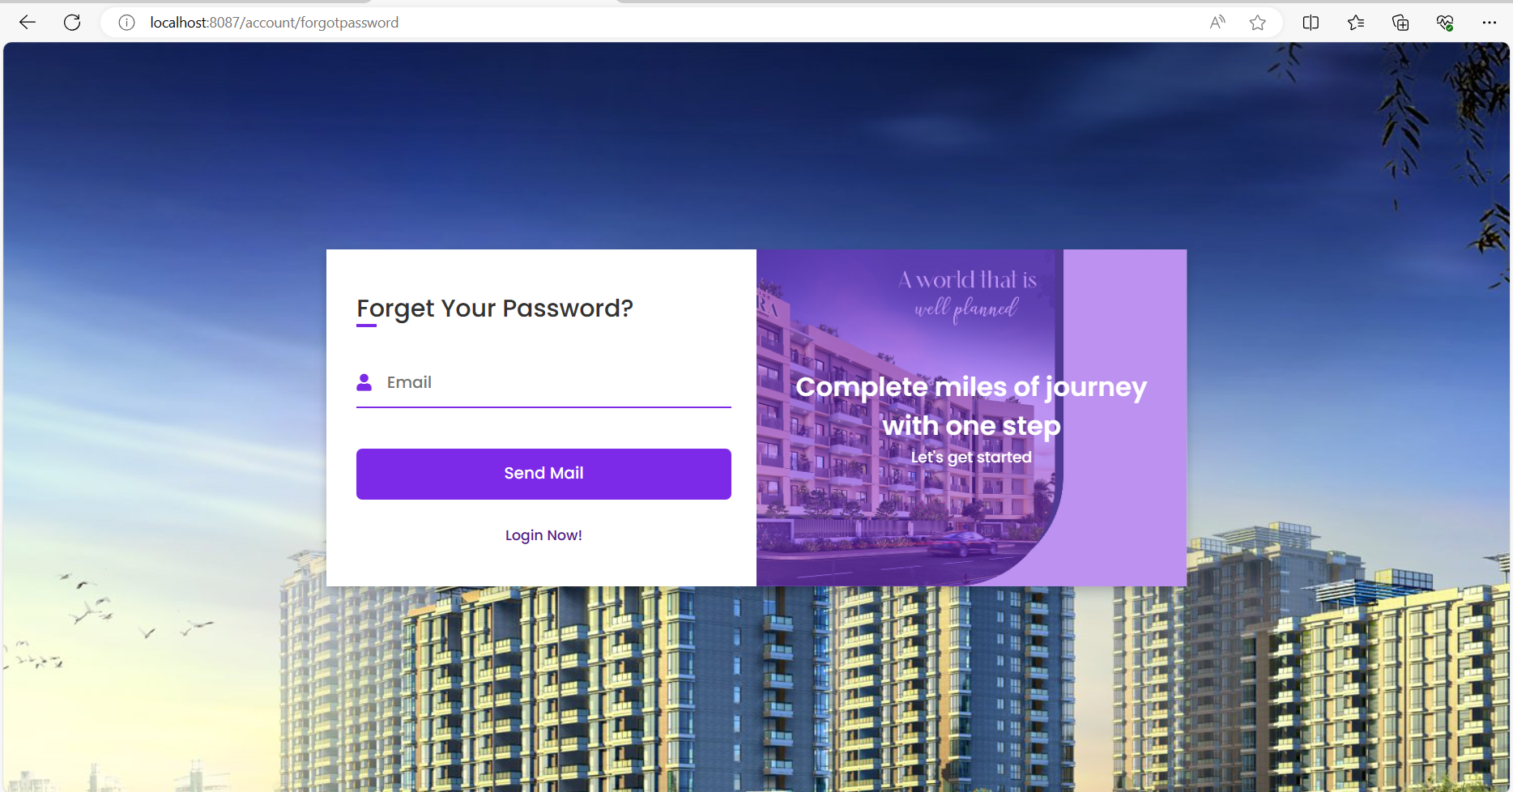

1. Register

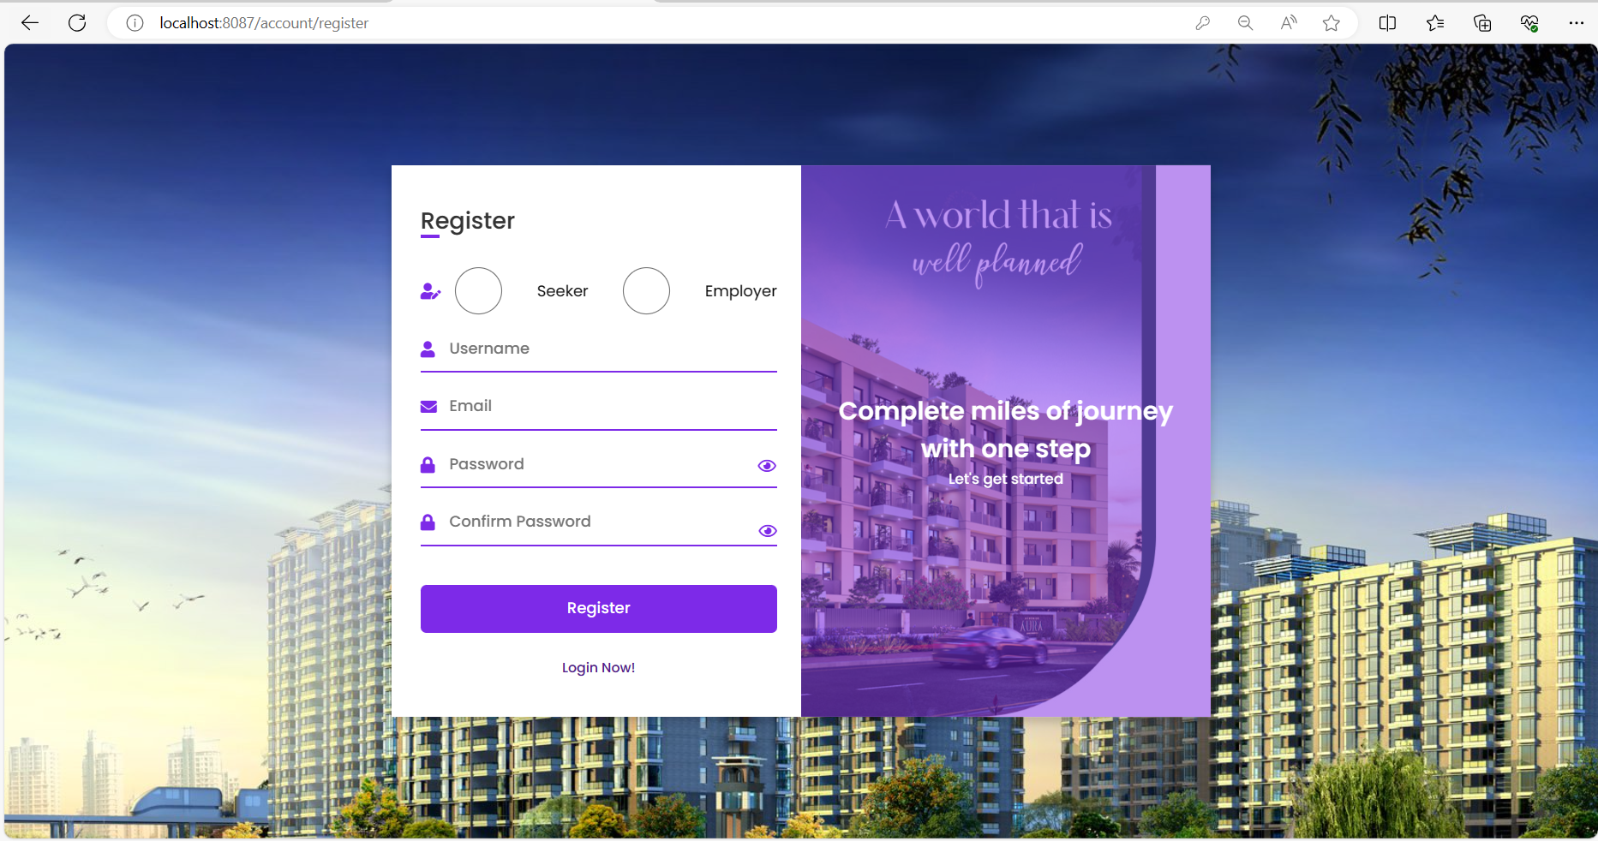

1. Personal Information/Change Password/ Personal Order

* Seeker

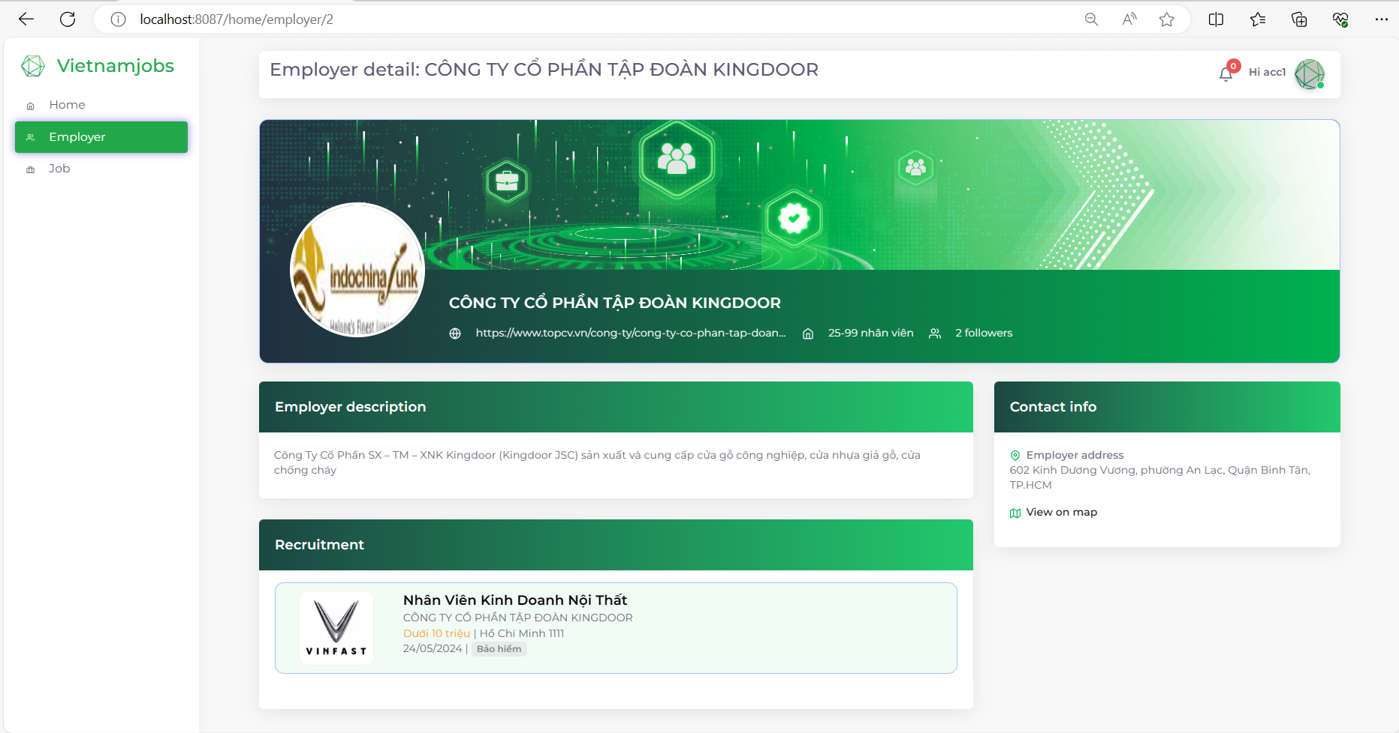

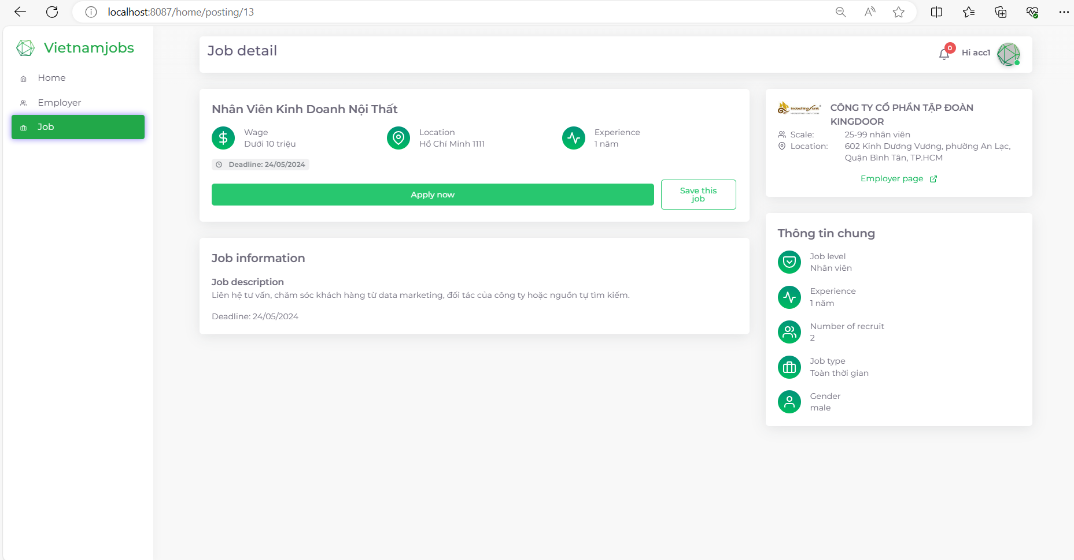

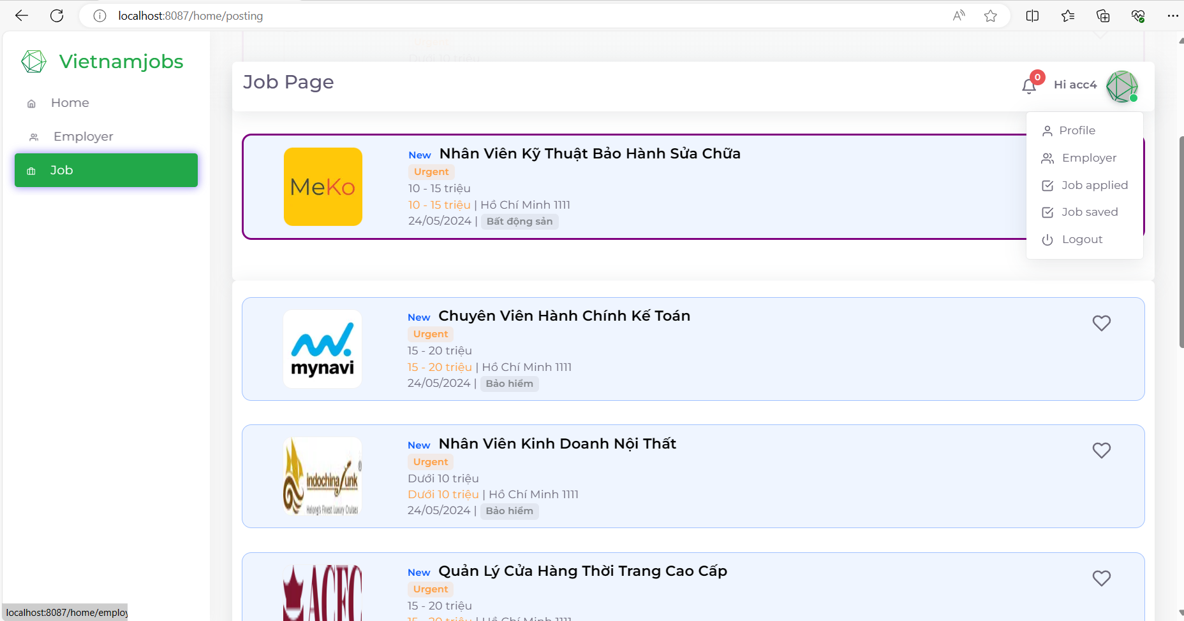

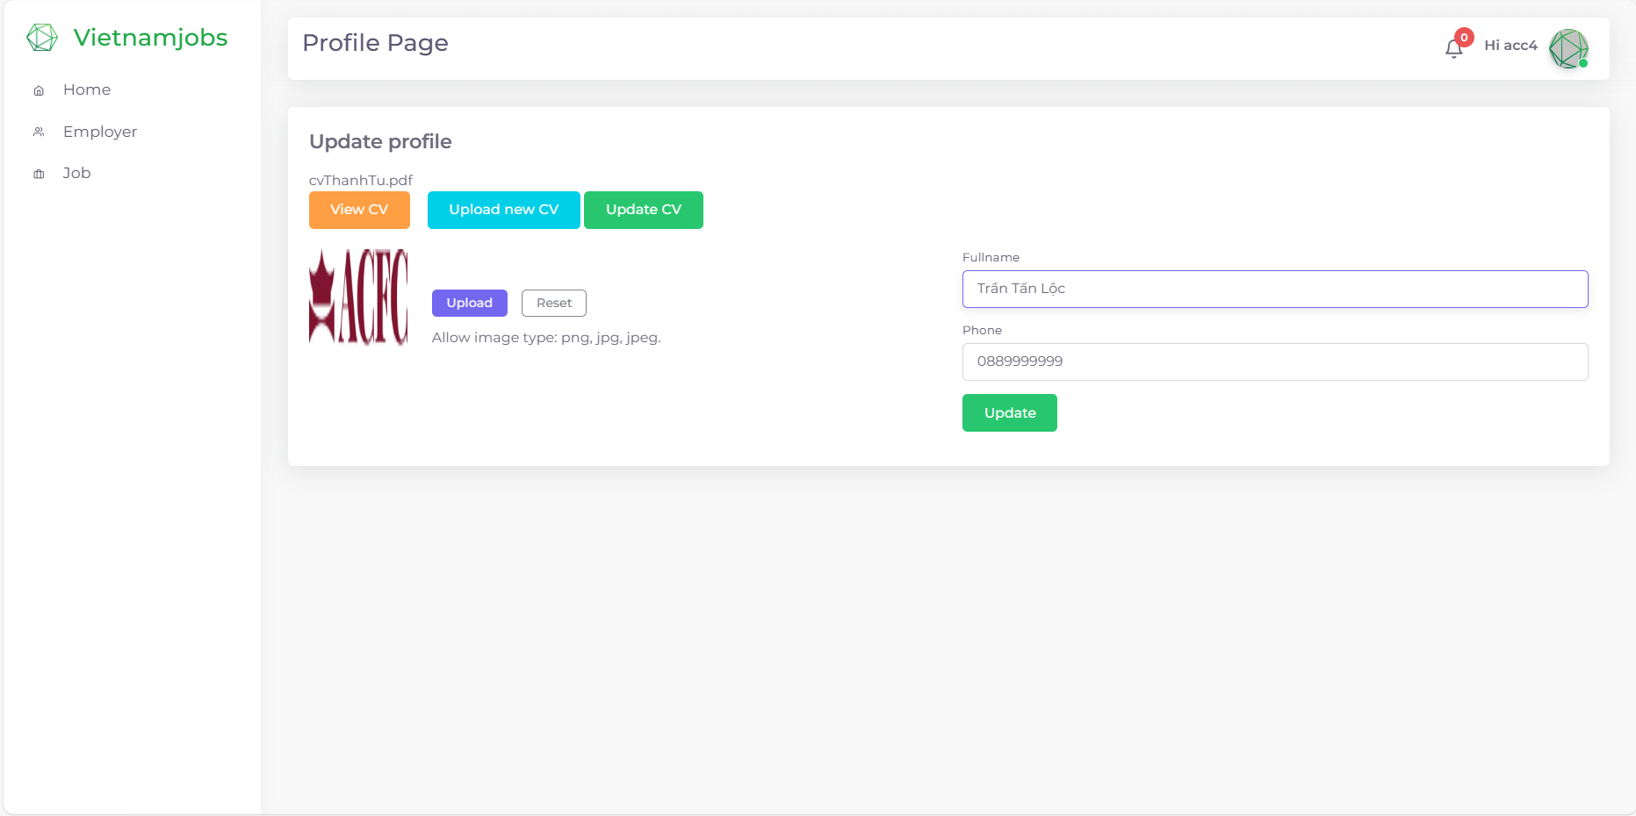

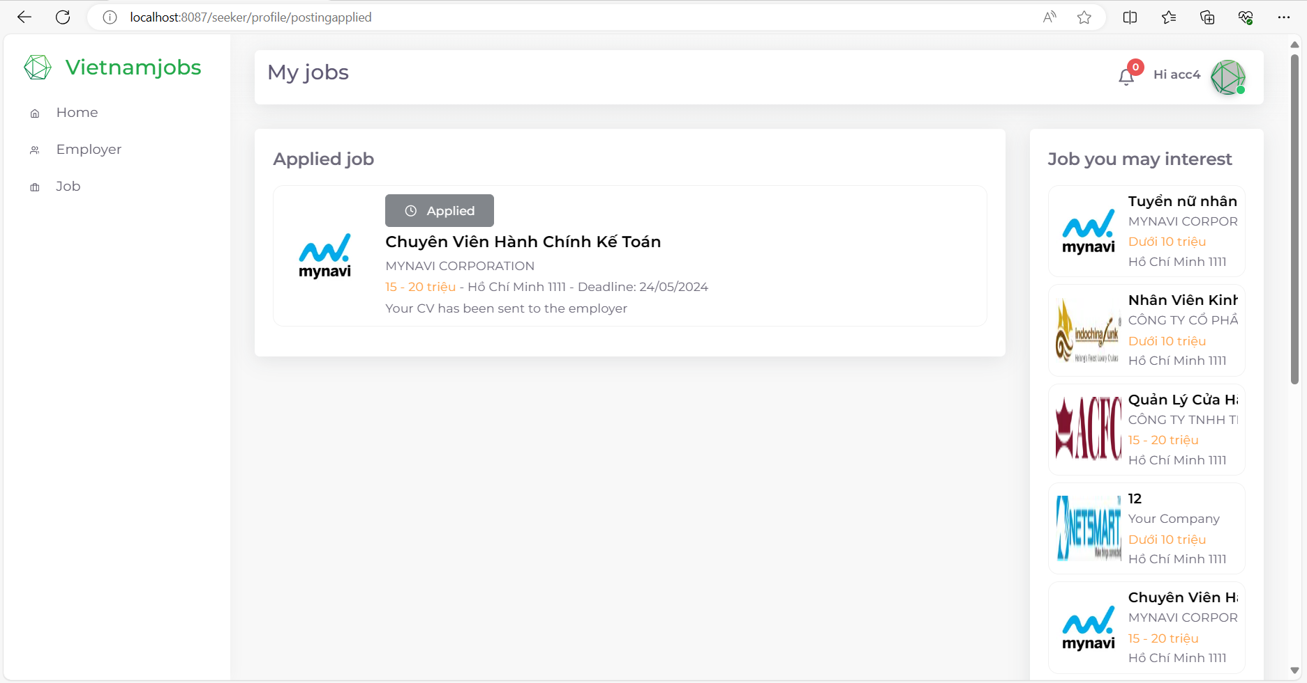

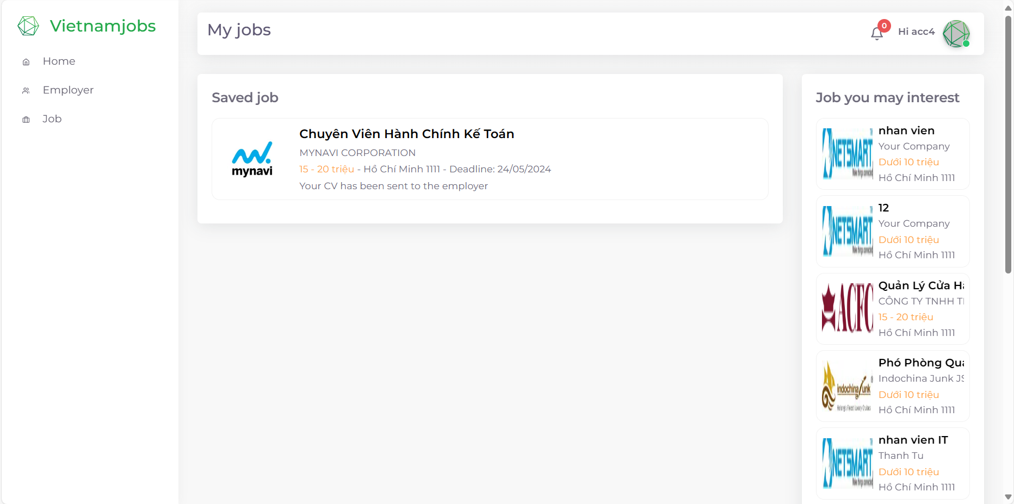

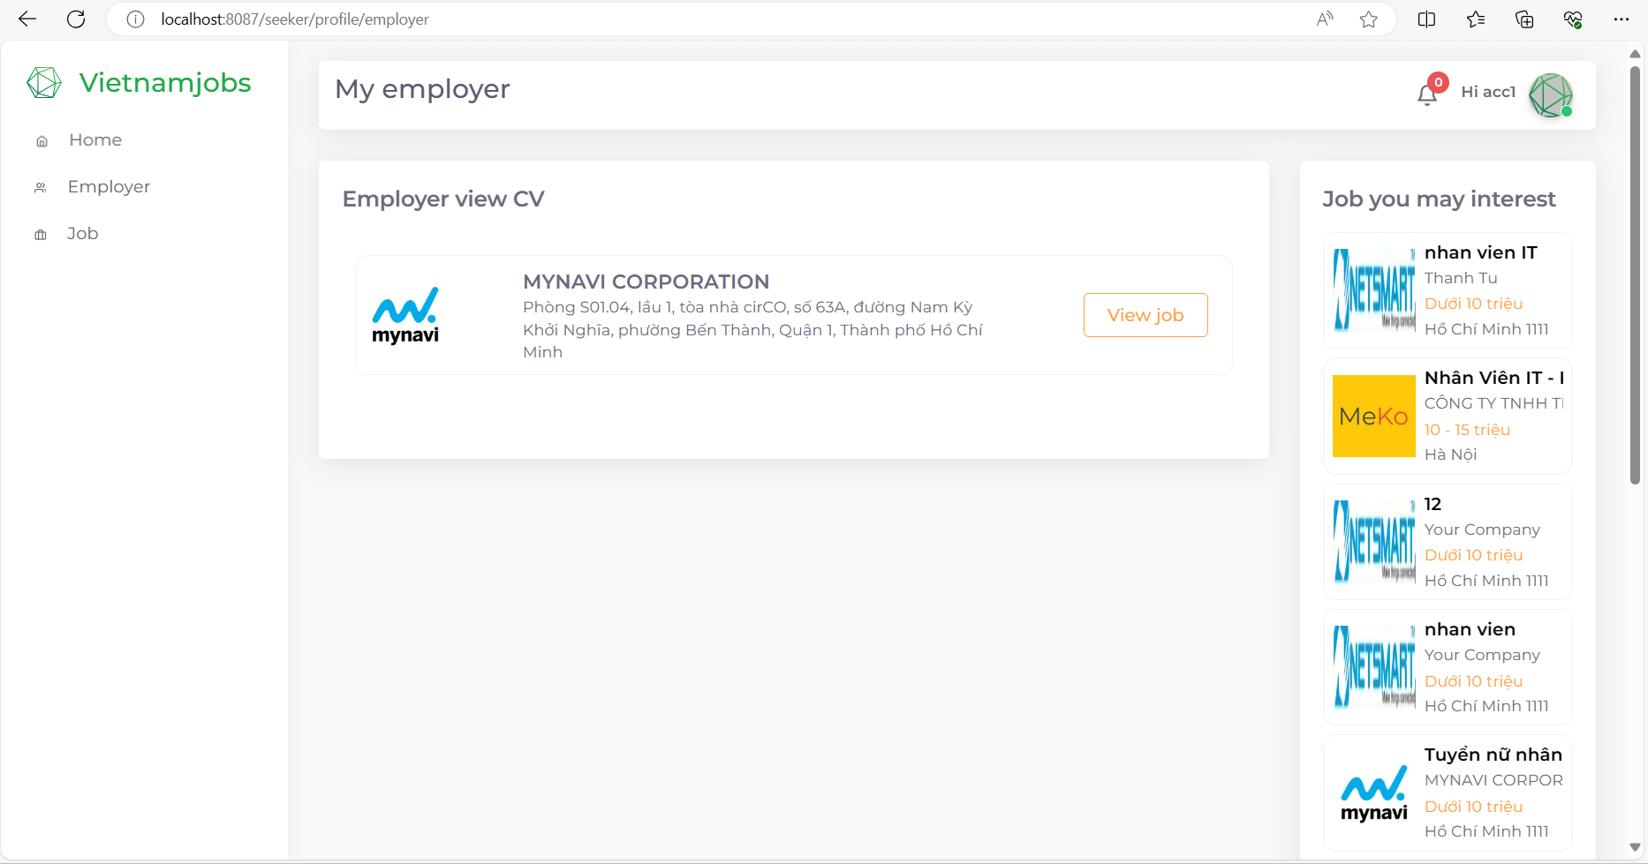

* Employer

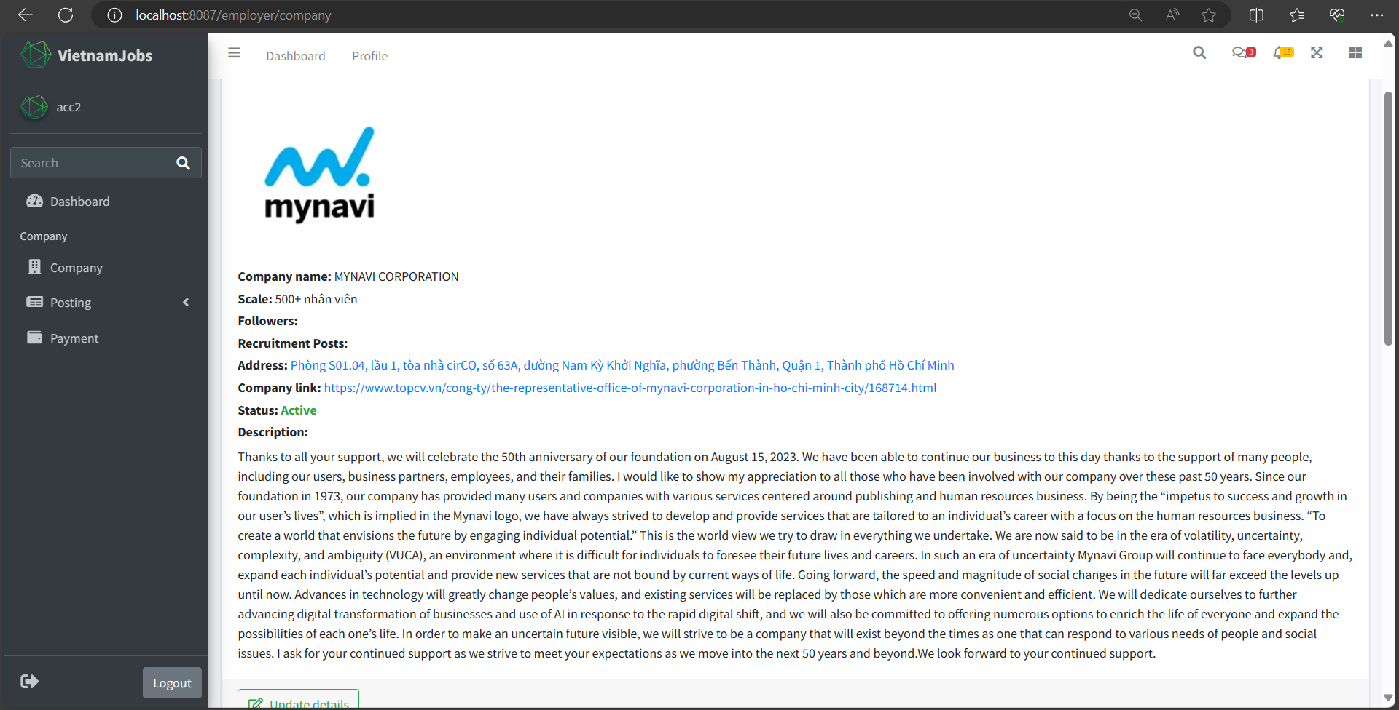

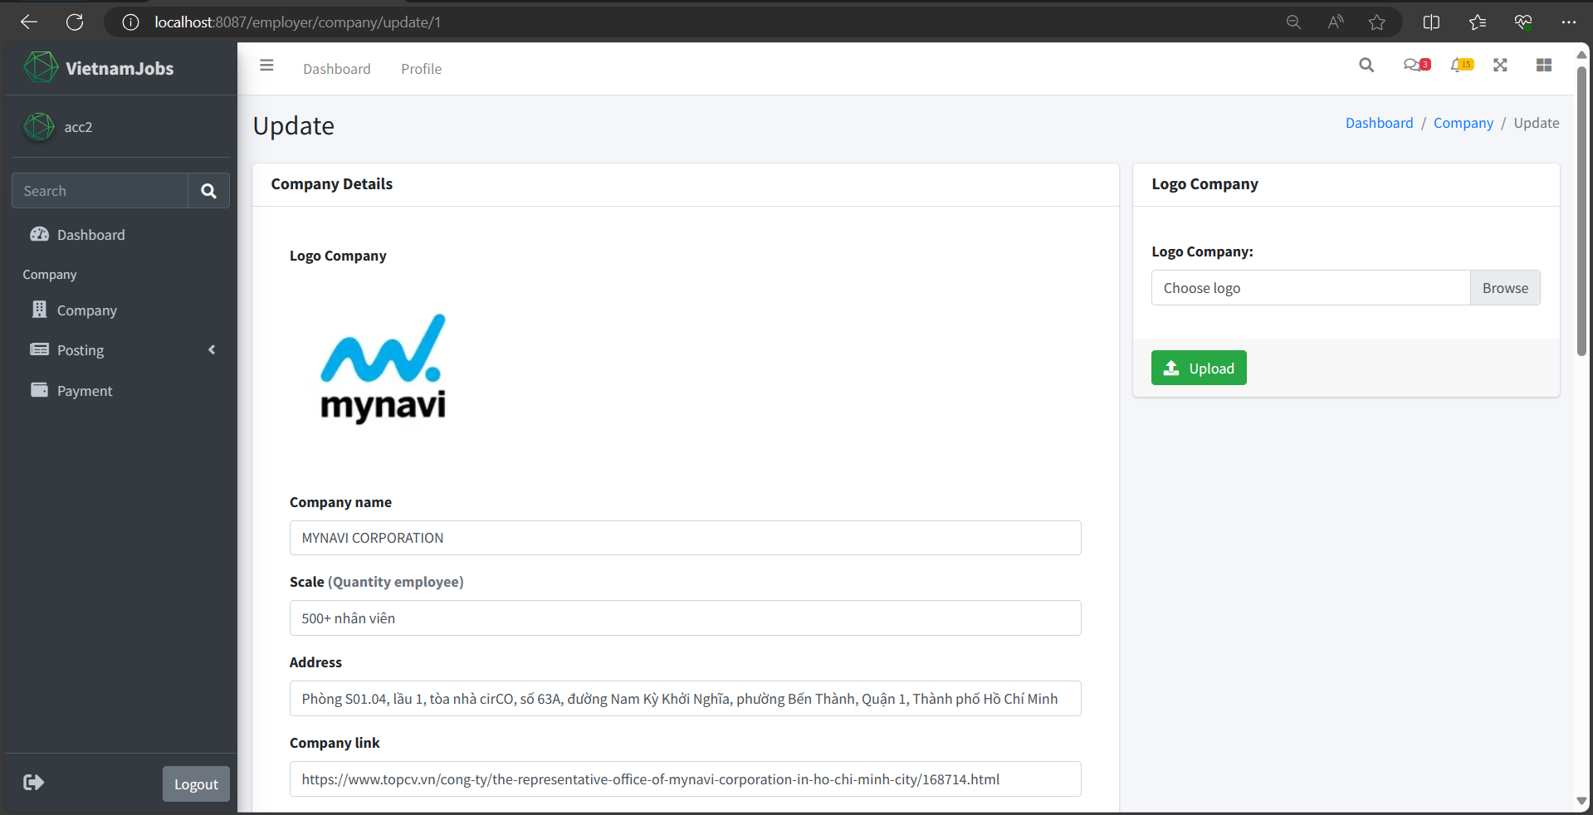

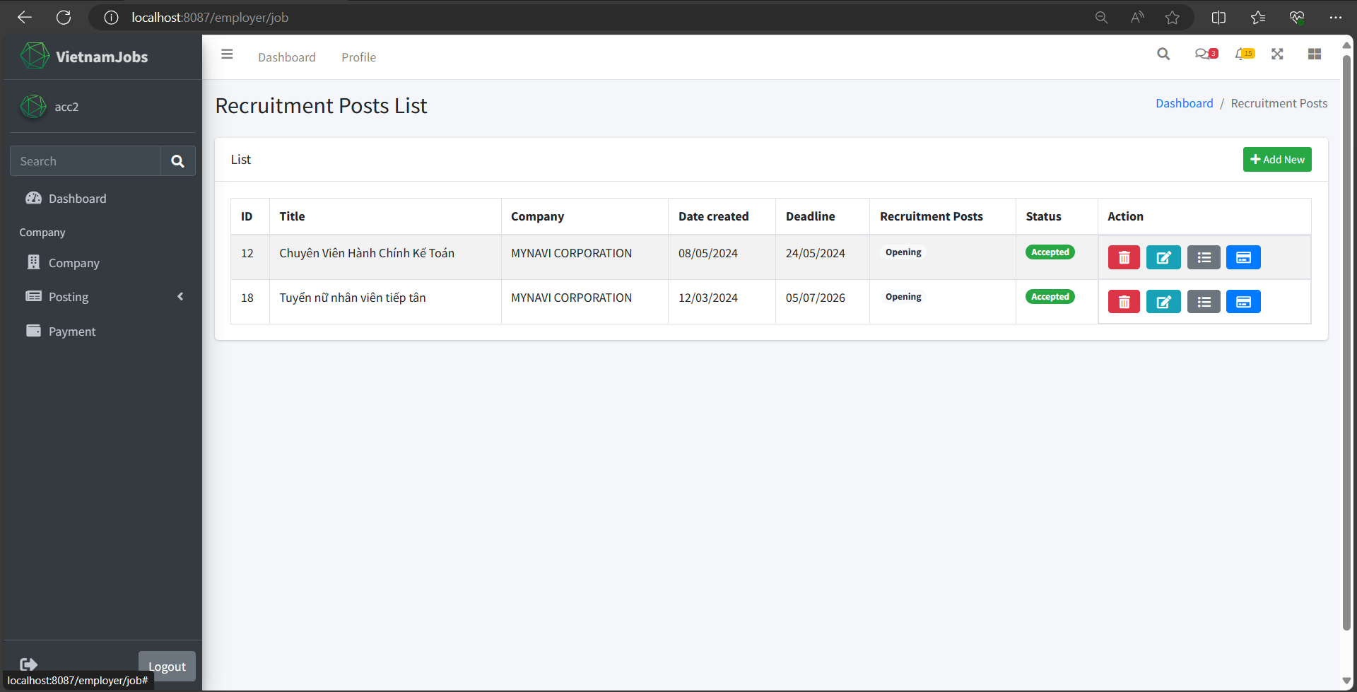

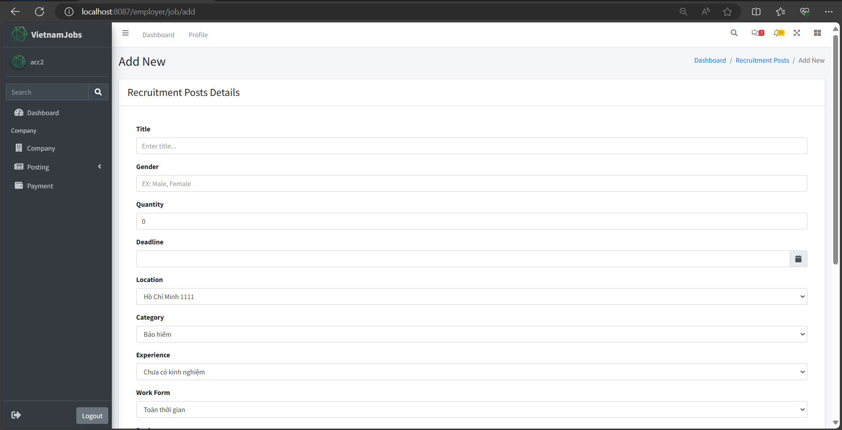

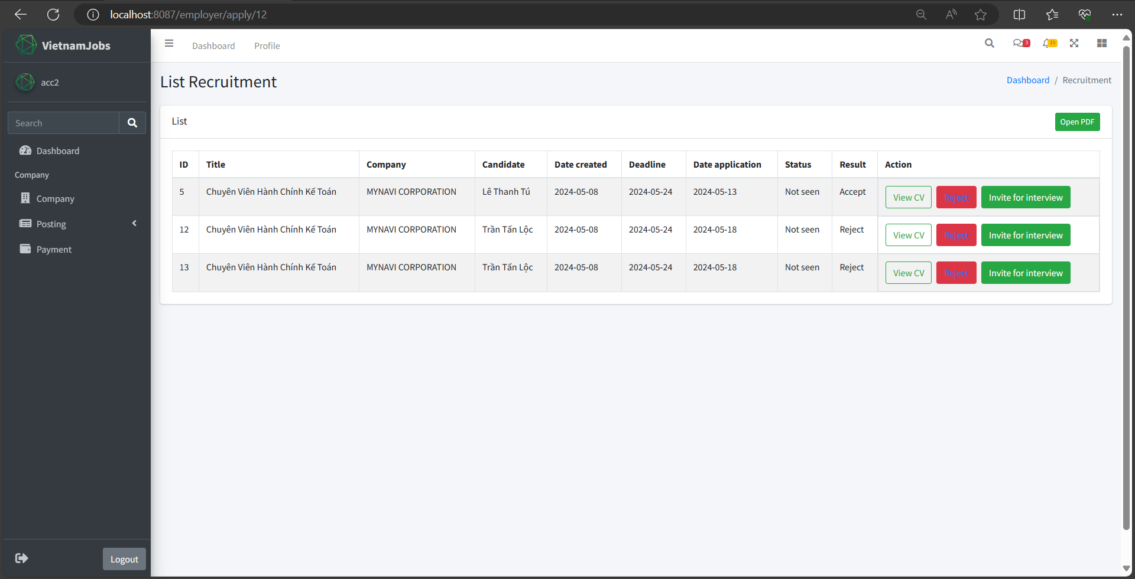

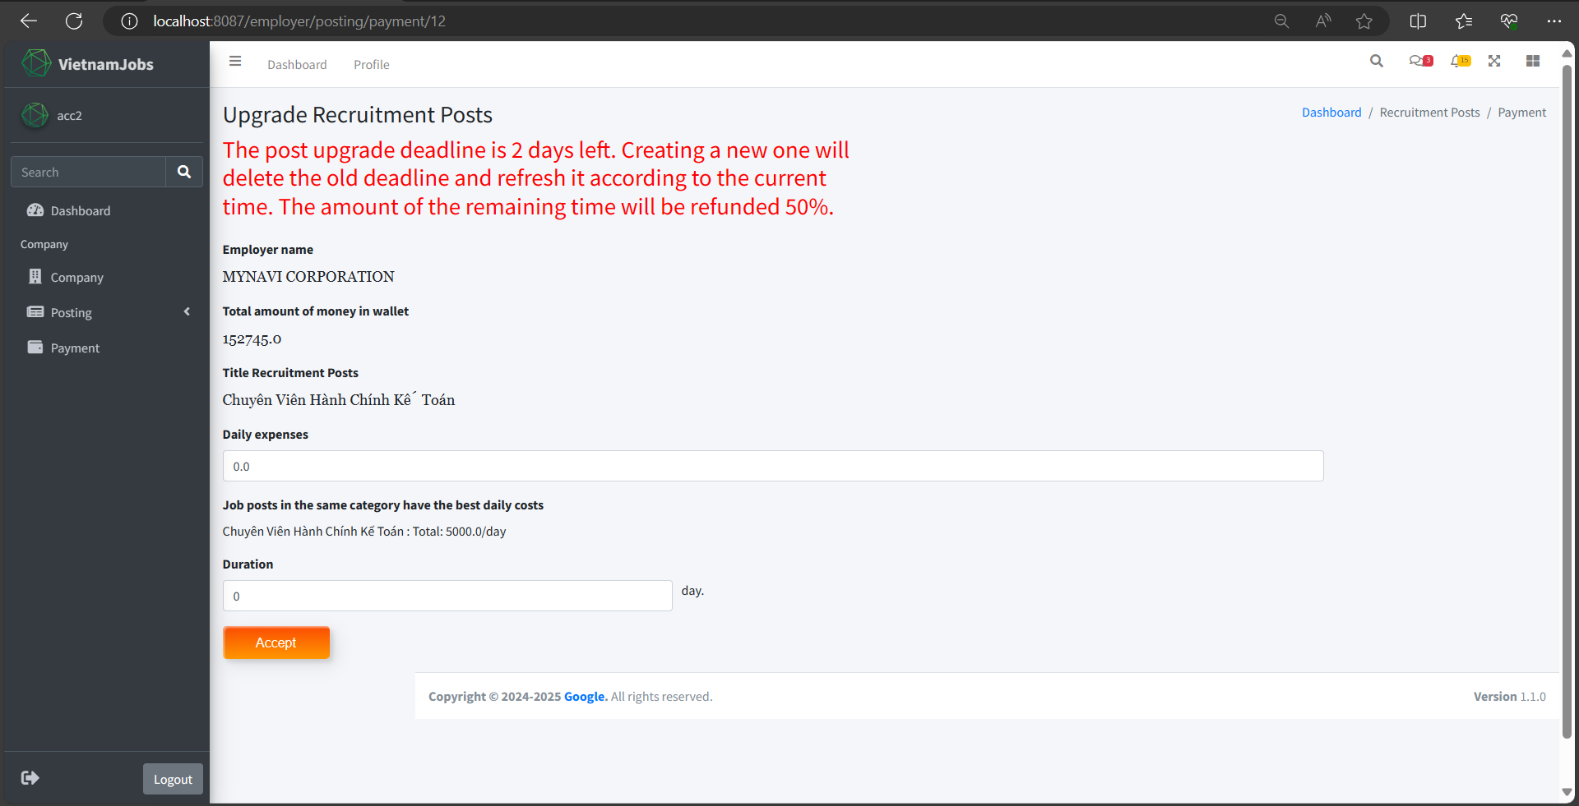

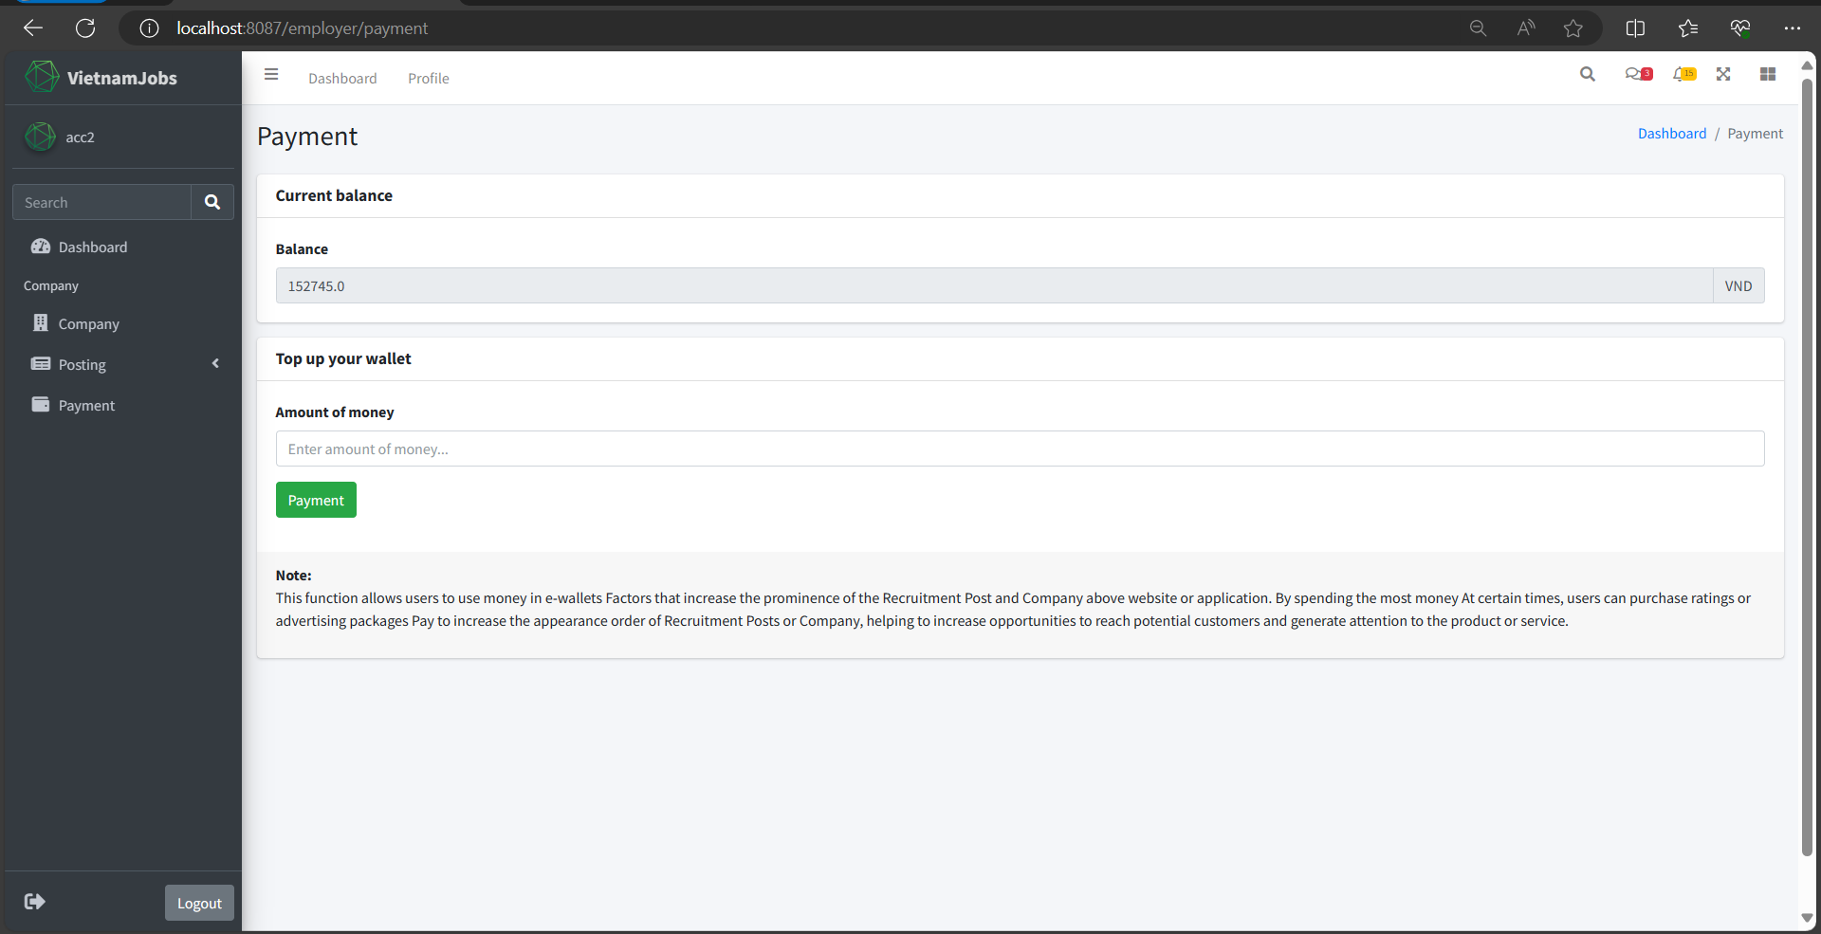

1. **Database**
2. ER Diagram

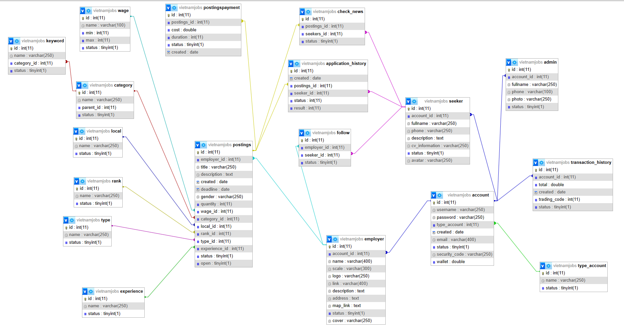

1. Detail of Tables

Account

|  |  |  |
| --- | --- | --- |
| **No** | **Name Field** | **Type** |
| 1 | id | int |
| 2 | username | Varchar(250) |
| 3 | password | Varchar(250) |
| 4 | type_account | int |
| 5 | created | Date |
| 6 | email | Varchar(400) |
| 7 | status | boolean |
| 8 | security_code | Varchar(250) |
| 9 | wallet | double |

Admin

|  |  |  |
| --- | --- | --- |
| **No** | **Name Field** | **Type** |
| 1 | id | int |
| 2 | account_id | int |
| 3 | fullname | Varchar(250) |
| 4 | phone | Varchar(100) |
| 5 | photo | Varchar(250) |
| 6 | status | boolean |

Employer

|  |  |  |
| --- | --- | --- |
| **No** | **Name Field** | **Type** |
| 1 | id | int |
| 2 | account_id | int |
| 3 | name | Varchar(400) |
| 4 | scale | Varchar(300) |
| 5 | logo | Varchar(250) |
| 6 | link | Varchar(400) |
| 7 | description | Text |
| 8 | address | Text |
| 9 | map_link | Text |
| 10 | cover | Varchar(250) |
| 11 | status | boolean |

Seeker

|  |  |  |
| --- | --- | --- |
| **No** | **Name Field** | **Type** |
| 1 | id | int |
| 2 | account_id | int |
| 3 | fullname | Varchar(250) |
| 4 | phone | Varchar(250) |
| 5 | description | Text |
| 6 | cv_information | Varchar(250) |
| 7 | status | Varchar(250) |
| 8 | avatar | Text |

Postings

|  |  |  |
| --- | --- | --- |
| **No** | **Name Field** | **Type** |
| 1 | id | int |
| 2 | employer_id | int |
| 3 | title | Varchar(250) |
| 4 | description | Text |
| 5 | created | Date |
| 6 | deadline | Date |
| 7 | gender | Varchar(250) |
| 8 | quantity | int |
| 9 | wage_id | int |
| 10 | category_id | int |
| 11 | local_id | int |
| 12 | rank_id | int |
| 13 | type_id | int |
| 14 | experience_id | int |
| 15 | status | boolean |
| 16 | Open | boolean |

Application_History

|  |  |  |
| --- | --- | --- |
| **No** | **Name Field** | **Type** |
| 1 | id | int |
| 2 | created | Date |
| 3 | posting_id | int |
| 4 | seeker_id | int |
| 5 | status | int |
| 6 | result | int |

Category

|  |  |  |
| --- | --- | --- |
| **No** | **Name Field** | **Type** |
| 1 | id | int |
| 2 | name | Varchar(250) |
| 3 | parent_id | int |
| 4 | status | boolean |

Check_news

|  |  |  |
| --- | --- | --- |
| **No** | **Name Field** | **Type** |
| 1 | id | int |
| 2 | posting_id | int |
| 3 | seeker_id | int |
| 4 | status | boolean |

Experience

|  |  |  |
| --- | --- | --- |
| **No** | **Name Field** | **Type** |
| 1 | id | int |
| 2 | name | Varchar(250) |
| 4 | status | boolean |

Follow

|  |  |  |
| --- | --- | --- |
| **No** | **Name Field** | **Type** |
| 1 | id | int |
| 2 | employer_id | int |
| 3 | seeker_id | int |
| 4 | status | boolean |

Keyword

|  |  |  |
| --- | --- | --- |
| **No** | **Name Field** | **Type** |
| 1 | id | int |
| 2 | name | Varchar(250) |
| 3 | category_id | int |
| 4 | status | boolean |

Local

|  |  |  |
| --- | --- | --- |
| **No** | **Name Field** | **Type** |
| 1 | id | int |
| 2 | name | Varchar(250) |
| 4 | status | boolean |

PostingsPayment

|  |  |  |
| --- | --- | --- |
| **No** | **Name Field** | **Type** |
| 1 | id | int |
| 2 | postings_id | int |
| 3 | cost | double |
| 4 | duration | int |
| 5 | status | boolean |
| 6 | created | Date |

Rank

|  |  |  |
| --- | --- | --- |
| **No** | **Name Field** | **Type** |
| 1 | id | int |
| 2 | name | Varchar(250) |
| 4 | status | boolean |

Type

|  |  |  |
| --- | --- | --- |
| **No** | **Name Field** | **Type** |
| 1 | id | int |
| 2 | name | Varchar(250) |
| 4 | status | boolean |

Type_Account

|  |  |  |
| --- | --- | --- |
| **No** | **Name Field** | **Type** |
| 1 | id | int |
| 2 | name | Varchar(250) |
| 4 | status | boolean |

Wage

|  |  |  |
| --- | --- | --- |
| **No** | **Name Field** | **Type** |
| 1 | id | int |
| 2 | name | Varchar(250) |
| 4 | status | boolean |

Transaction_history

|  |  |  |
| --- | --- | --- |
| **No** | **Name Field** | **Type** |
| 1 | id | int |
| 2 | account_id | int |
| 3 | total | double |
| 4 | created | Date |
| 5 | trading_code | int |
| 6 | status | boolean |

**CONTRIBUTIONS**

|  |  |  |
| --- | --- | --- |
| **No.** | **Team Member Name** | **Contributions** |
| **1** | **Tu Le Thanh** | - User interface (UI/UX) design and user experience on app Mobile |
|  | - Building API for integration with external systems. |  |
|  | - Writing detailed documentation for API and integration. |  |
| **2** | **Loc Tan Tran** | - User interface (UI/UX) design and user experience on app Mobile |
|  | - Building API for integration with external systems. |  |
|  | - Participation in testing and bug fixing. |  |
| **3** | **Ai Phan Hoang Kha** | - Admin interface (UI/UX) design and user experience |
|  | - Coding for the post management module. |  |
|  | - Participation in testing and bug fixing. |  |
| **4** | **Huong Truong Van** | - Development of search and data sorting features. |
|  | - Participation in testing and bug fixing. |  |
|  | - Development of search and data sorting features. |  |
| **5** | **Hieu Nguyen Trong** | - Development of search and data sorting features. |
|  | - Coding for the user management module. |  |
|  | - Participation in testing and bug fixing. |  |